Hooks

Why hooks?

- Reusing logic between multiple components.
In React our main building block of our application is a component.
And component form the foundation of the two main pattern for sharing code in react apps between components.
Higher order components
And render props
Both of these patterns are great for some cases but they also come with a significant downside.
We need to restructure our app any time we want to pull on of these in.
In a more complicated cases this leads to what we call “wrapper hell”
The nesting we end up with makes it difficult to follow the data flow through the app. It would be really nice if there would be some way to use the stateful logic without needing to
change the component hierarchy.

- Giant components whose logic is come sort of tangled mass
When we see a thousand line react component chances are that logic is split across a different life cycle methods in way that is pretty difficult to follow.

Let’s say we have a class component and in its componentDidMount method does a few different things.
It subscribe to a data store, Sends off a network request, And starts a timer,
Well if we see the componentWillUnmount mehtod then we are going to see basically the exact 3 opposite things
In needs to unsubscribe from the store, Cancel that network request and Stops the timer.
And when it comes to componentDidUpdate the logic tends to get even trickier because we need to compare all the props and also mirror it again the same task that we have in our
Life cycle methods.
The example is quite simple, in real world components we often end up with even more tangled mess because each individual task has to be split across different life cycle methods
That makes it hard to tell if for instance we forget to clean up one of the resources when we are unmounting our component
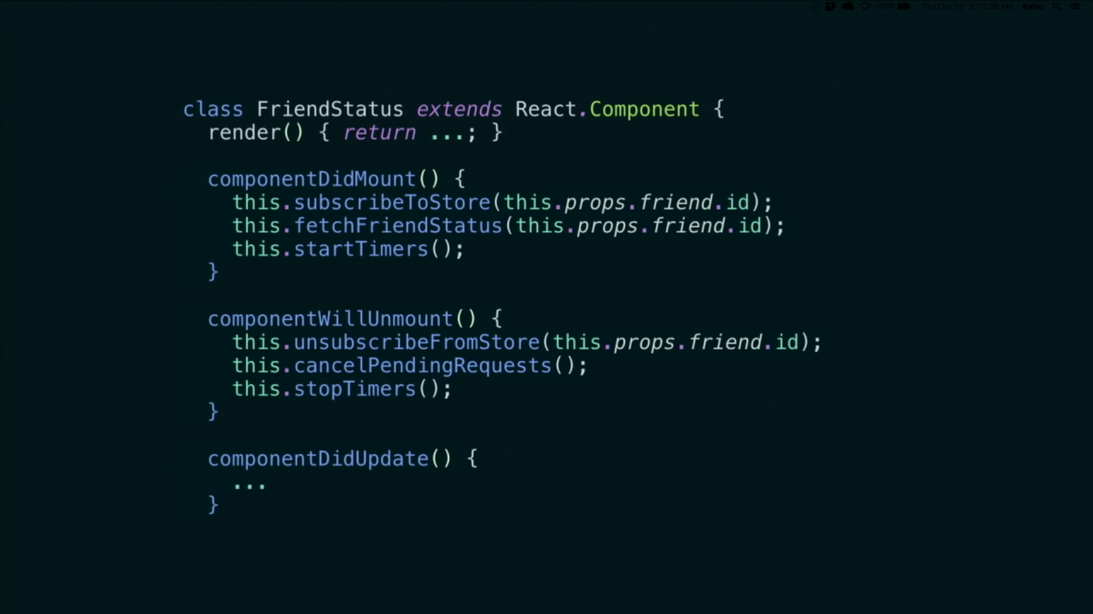

- Confusing classes understanding classes in javascript can be pretty tricky and we require to use class components in order to access state and life cycles.
If we take a functional component and try to convert it into a class to add some state we know that there is fare amount of boiler plate that is required to just define a class component.
The way binding and this work in classes is pretty confusing it’s annoying to have to think about
We don’t exactly know when to use functional component because there is some fear that we gonna have to convert it to a class component
Classes are hard for humans and also for machines
A minified component file we will see that all the method names are still minified
And if we have a method that is completely unused it doesn’t get stripped out that’s because it’s hard to tell at compiled time exactly how all the methods fit together
Classes also makes it difficult to implement hot reloading reliably and when we are prototyping and optimizing compiler to improve the performance of react components we can see that
Classes encourage some patterns that makes it harder for compiler to optimize.

All the problems with react mentioned above, wrapper hell, huge components and confusing classes need to be addressed even if it was the most popular JS library without the hooks.
We can approach them one by one.
But it seems like solving one of them make other one worse.
For example if we try to solve wrapper hell by putting more logic into component then our components become larger and harder to refactor.
And on the other hand if we want to split the components apart into smaller pieces and reuse those the we end up with more nesting into component tree and we get the wrapper hell again.
And finally in either case we have all the confusion that comes with the classes.
This is because these are not three separate problems
These are actually 3 symptoms of one problem.
And the problem is that react does not provide a simpler smaller lightweight primitive to add state or lifecycle than a class component.

How to solve?

The proposal.
No breaking changes or deprecations it is strictly additive
It adds some new API’s

Here we have a simple react component we have a Row having some styling and it renders a persons name.
import React from "react";
import Row from "./Row";

const Greetings =(props)=>{
return(
<section>
<Row label="Name">
{props.name}
</Row>
</section>
)
}
export default Greetings;

What if we want this name to be editable
In react normally if we want to add an input there we have to turn this component into a class add some local state to it and let the local state drive the input
import React from "react";
import Row from "./Row";
export default class Greetings extends React.Component {
constructor(props) {
super(props);
this.state = {
name: "Mary",
};
handleNameChange = (e) => {
this.setState({ name: e.target.value });
};
}
render() {
return (
<section>
<Row label="Name">
<input
value={this.state.name}
onChange={this.handleNameChange}
></input>
</Row>
</section>
);
}
}

But what if we didn’t have to write a class when we wanted to use state
import React from "react";
import Row from "./Row";

const Greetings = (props) => {
const name = ???
const setName= ???
const handleNameChange = (e) => {
setName(e.target.value);
};
return (
<section>
<Row label="Name">
<input value={name} onChange={handleNameChange}></input>
</Row>
</section>
);
};
export default Greetings;
if we render an input inside the row input has the value and the values is the current name but where to get name from it doesn’t come from props let’s declare a name variable above
we also need a onChange
Which going to be a handler which we can declare above with setName to e.target.value but we don’t have the setName function with us let’s declare it also.

We can see two things there one is the name which is the current value of the state variable and one setName function that let’s us set the state
Because the two are closely related we can put them together like [name ,setName]= ???
We need to get them together from somewhere
So where to get them from
From react local state
So how to use react local state from a functional component.
So what is we could just useState
And pass the initial state to specify

import React,{useState} from "react";
import Row from "./Row";

const Greetings = (props) => {
const [name, setName] = useState("Mary");

const handleNameChange = (e) => {
setName(e.target.value);
};
return (
<section>
<Row label="Name">
<input value={name} onChange={handleNameChange}></input>
</Row>
</section>
);
};
export default Greetings;

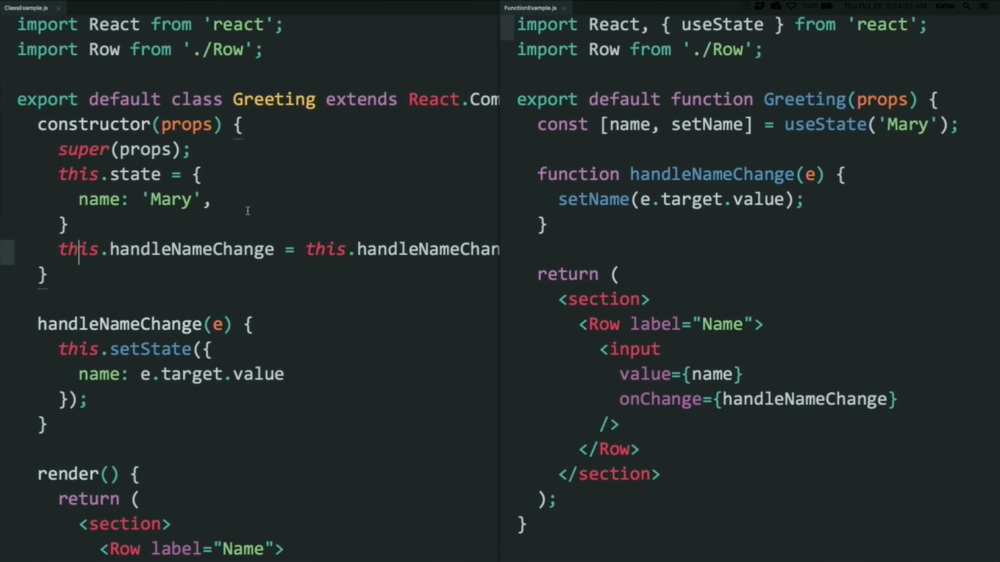

On the left we have a familiar class component the state has to be an object.
We bind some event handlers so that we can access this inside the event handler for this.state.
When we call this.setState if actually doesn’t just set the state it merges the state argument in the state object
And then we want to access the state we use this.state.something

In example on the right we don’t need to access this.state.something because the name state variable is already available in the function its just a variable
And we need to set the state we don’t need to access this.something because the function that let’s us set the name is also available in the scope.

useState()
useState() is a hook.
A hook is a function provided by react that let’s us hook into react features from our functional components.

Other thing we might want to do from a component is to read context.
Contexts are kind of global variable for a subtree, useful for things like theming the current language the user is using and it’s useful to avoid passing every things through props if we need all components to read some value.
We can create context using the React.creatContext fucnction and then we can import the context into the component where we indent the context and then we use the for example
<ThemeContext.Consumer> to wrap the the component .

With hooks
As we know that the state is the fundamental feature of react that’s why we can useState so if we want to use context we import the context
for example import {ThemeContext} from “./ThemeContext”
And to use we can useContext
const theme = useContext(ThemeContext)
And then we can use the context as we have specified in the.

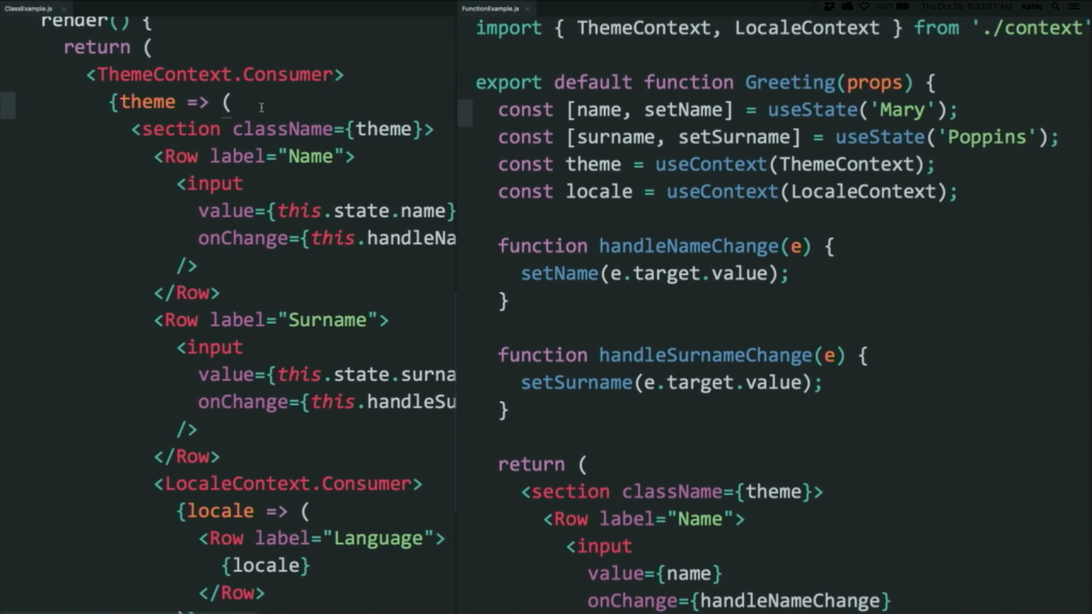
When we compare the two approaches
The traditional render prop api it is very explicit about what it is doing but it gets a bit nested
Hooks does the same thing but it’s flat.

The two useState calls we might be wondering how does react know which state variable corresponds to which use state call.
And the answer is that react relies on the order of these calls.
In order to work correctly we need to follow a rule when we use hooks and the rule is that we cannot call a hook inside a condition it should be at a top level of our component.

Life Cycle methods
The most common use case of a lifecycle method is that we want to perform some side effect.
Such as firing of a request
Performing some kind of imperative DOM mutation.
Interfacing with the browser API’s
So we might do some thing like this but we can’t to while rendering because it’s not rendered yet.
So what we do in react that we declare a life cycle method like component did mount.

Lets for example we want to update the document title using the browser Api.
So let’s say that we want the top title to be the name of a person
To do this inside of component did mount we can use the document.title = this.state.name+ ‘ ‘ + this.state.surname.
We can see it says mary poppins
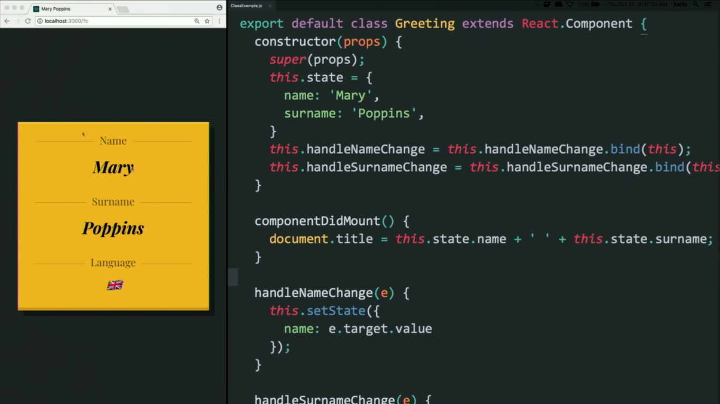

But then if we edit it in the input it will not get automatically updated in the title because we also need to implement component did update for the side effects to be consistent with we what we rendered.
Therefor we will include component did update and copy the same code.
This is how we perform in a class
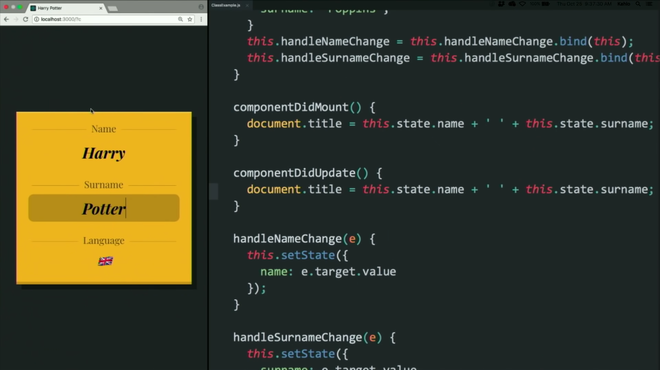

With hooks
useEffect
the ability to perform side effects is another core feature of react components.
So if we want to use an effect from our component we import useEffect from react.
We want to tell react what to do after react has flushed the components to the DOM.
So inside of useEffect we pass a function where we want to perform our effect.
And if we start editing it updates.
By default useEffect runs both after the initial render and after every update so by default it is consistent with what it renders.
And we can opt out of this behaviour like for performance reasons or if we have special logic
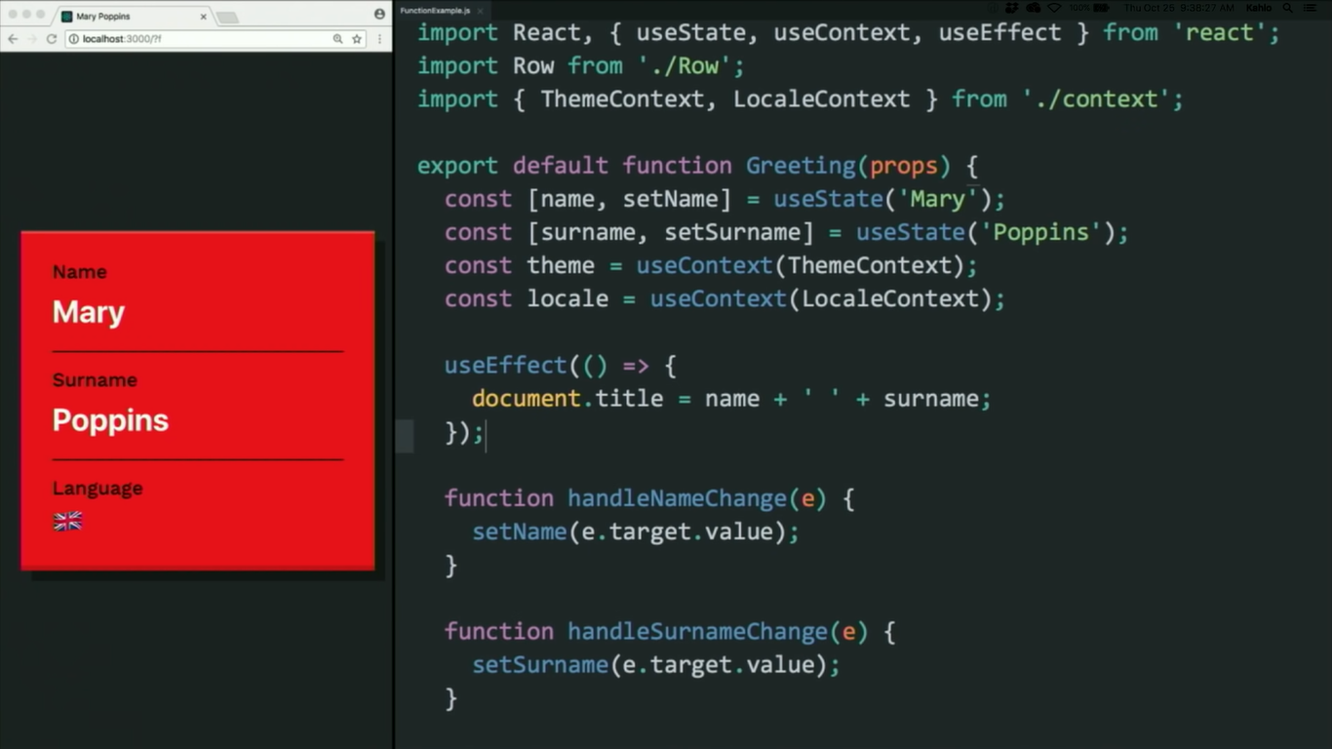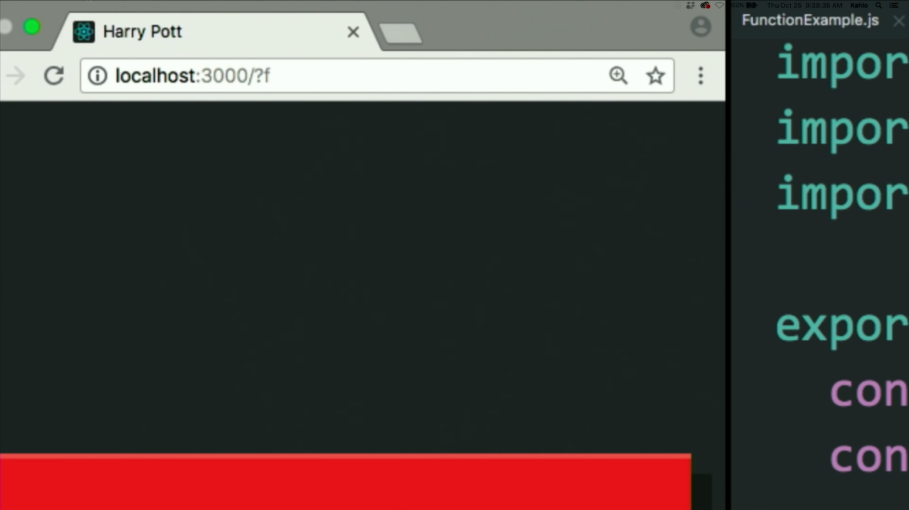

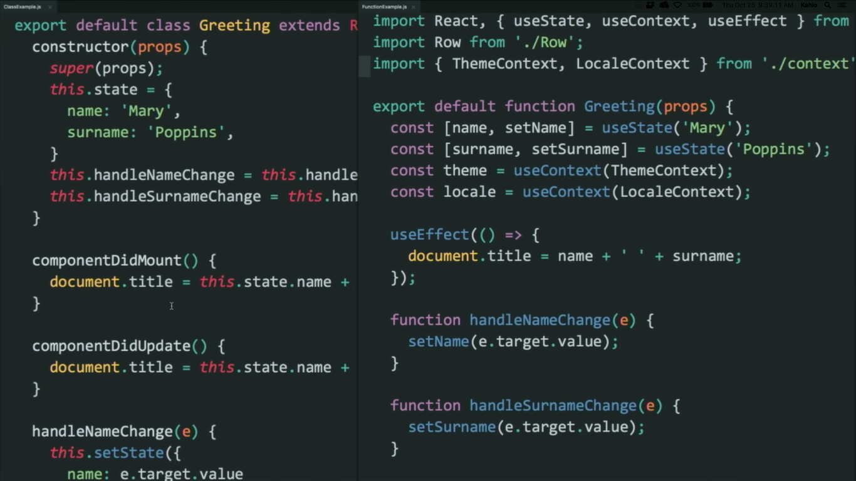
In the class we divide the logic based on the life cycle method so we have componentDidMount componentDidUpdate they fire at different times. We some time repeat logic between them we could extract into a function but still we have to call it into places and remember to keep it consistent.
With useEffect hook the effects are consistent by default although there is a way to opt out of that and in the class we need to access this.state so we need a special API to do it.
But with effect we don’t need any special API to do this as it is inside the scope of the function and that is why effect is declared inside of the component rather that outside. Because it gives access to state variables ability to set them or any thing else like context value

Another thing for which might want to use life cycle methods is subscriptions.
May be we want to subscribe to some kind of browser api for example the window size and we want to update the state in response to changes to these value.
So the way we can do this in a class lets say we want o monitor the window width.
We will put the width in the state
width: window.innerWidth
Then we will add the eventlistener in the life cycle method which will listen to the resize event and will perform the handle resize operation. And then we will update the width state to window.innerWidth.

And then to unsubscribe from the event we will create another life cycle method called componentWillUnmount
And we will use the remove eventlistner
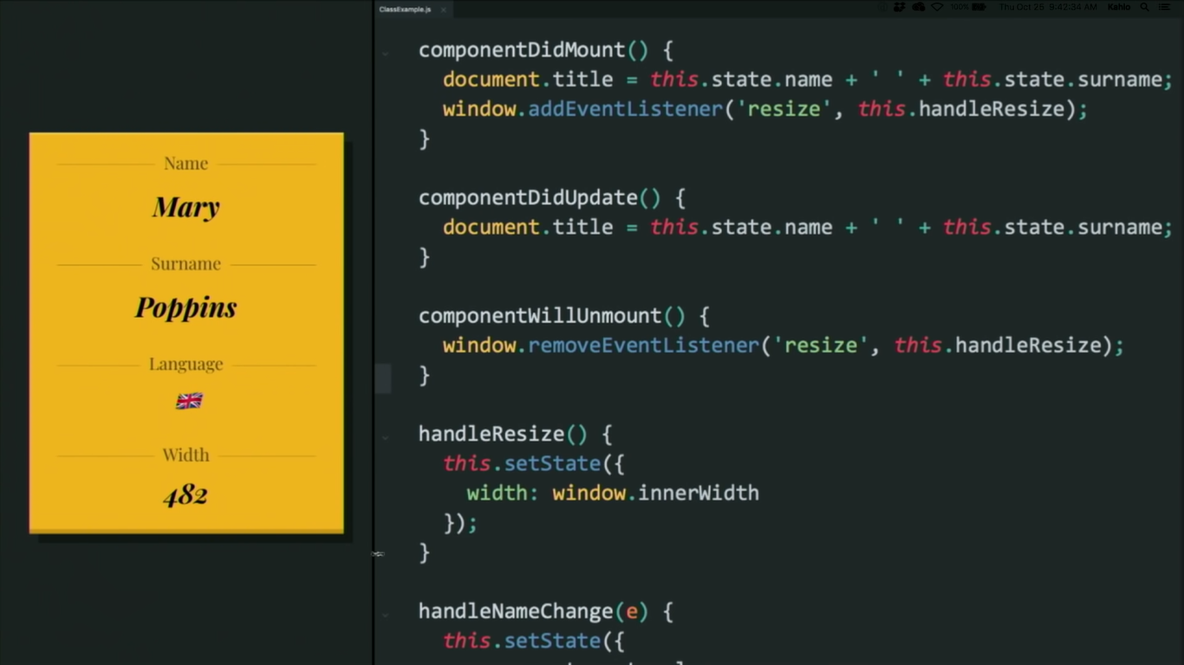

With Hooks
Conceptually listening to the window width has nothing to do with setting the document title so that’s why we will not put in that effect its conceptually completely different effect and just like we can use state more than once to declare multiple state variables we can use effect more than once to perform different side-effects .
And we also need width and set width so we will declare another state.
And then our handleResize will set the width
And we need to clean up after this effect so we need to specify and conceptually cleaning up is a part of this effect so this effect has a cleanup phase.
The way we can specify is that optionally any effect can return a function and react will call this function to cleanup after this effect

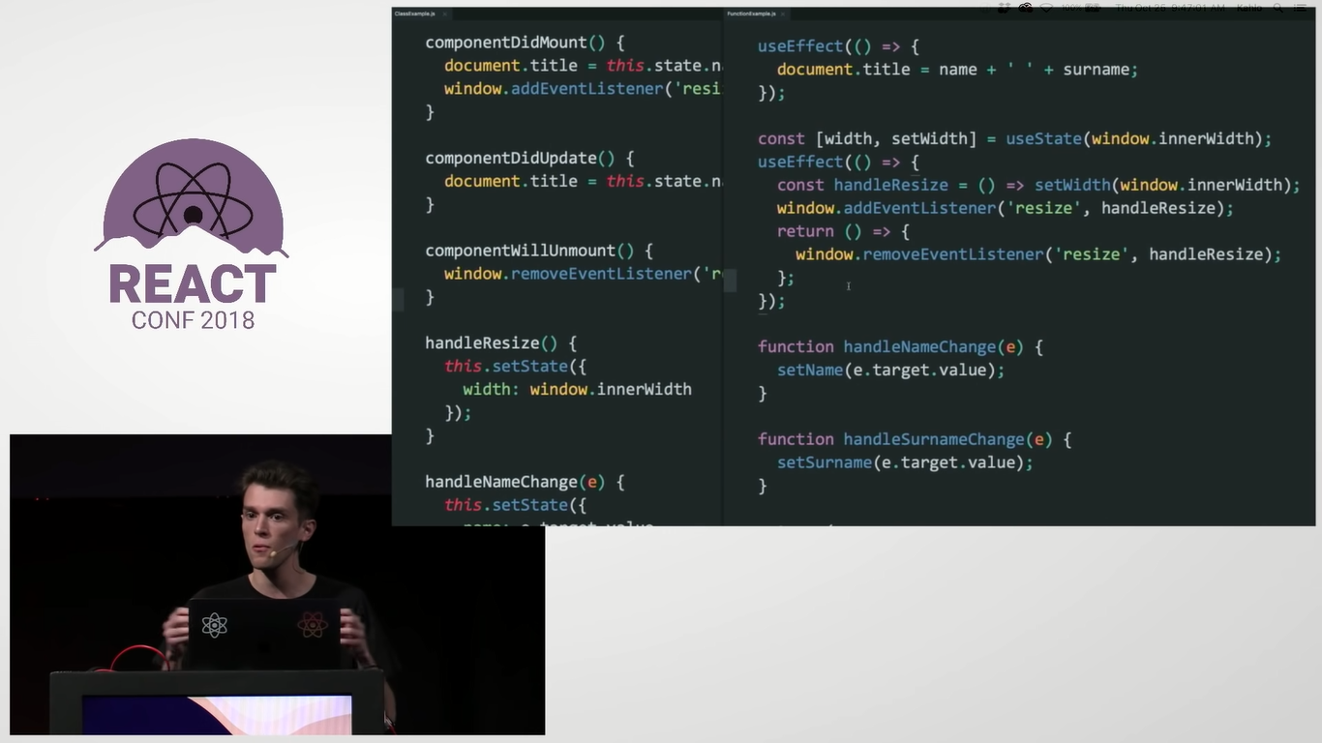

To configure useEffect we pass the second argument which can have any 3 of the following values.
1. empty array [ ] which will only run the code inside the first argument when the component rerenders for the first time only
2. nothing will only run the code inside the first argument when the component renders for the first time and whenever it rerenders
3. [data] will only run the code inside the first argument when the component is rerendered for the first time and when some piece of data has changed.

useEffect clean up function
Whenever we define useEffect or call it and we provide function as the first argument there’s only one possible value that we can return from an arrow function
Is another function the goal of this function is to essentially do some cleanup.
function FriendStatus(props) {
const [isOnline, setIsOnline] = useState(null);

useEffect(() => {
function handleStatusChange(status) {
setIsOnline(status.isOnline);
}
ChatAPI.subscribeToFriendStatus(props.friend.id, handleStatusChange);
// Specify how to clean up after this effect:
return function cleanup() {
ChatAPI.unsubscribeFromFriendStatus(props.friend.id, handleStatusChange);
console.log(I am working)
};
});

if (isOnline === null) {
return 'Loading...';
}
return isOnline ? 'Online' : 'Offline';
}
Understanding what this function is capable of is understanding when react is going to call this function.
React is going to keep a reference of this function and is going to call hat function for us automatically at some future point in time at the initial render it’s not going to call the function.
When the function in the first argument is executed once and the component rerenders then only this function will be called to do the clean up.

Custom hooks
We might want to reuse some logic in other component extract is or test it separately.
Hook calls are just functional calls and components are just functions so how to share logic between two functions
We extract it to different function
We can create a new function for our window size component called use window width and then extract the logic of setting the width using useState and then adding and removing evenlistners using useEffect inside of the useWindow function which will return width and the we can declare const width =useWindow(width).
We are calling this function a custom hook and by convention customhook names always start with hooks.
This let’s eslint automatically for violation of the first rule about calling hooks unconditionally. If we didn’t know something is a hook we wouldn’t be able to that.
And just kind wanna know id the function has some state inside of it
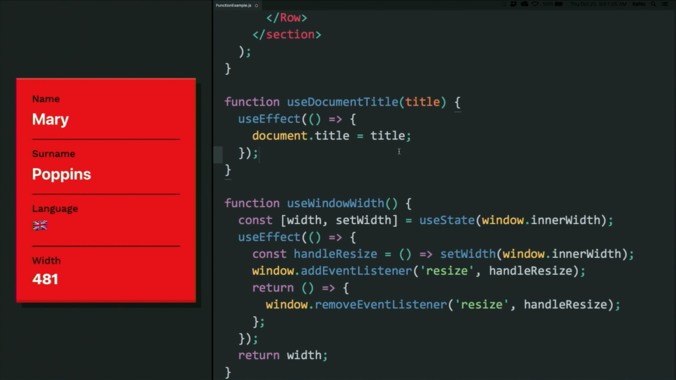

useContext

const value = useContext(MyContext);
Accepts a context object (the value returned from React.createContext) and returns the current context value for that context. The current context value is determined by the value prop of the nearest <MyContext.Provider> above the calling component in the tree.
When the nearest <MyContext.Provider> above the component updates, this Hook will trigger a rerender with the latest context value passed to that MyContext provider. Even if an ancestor uses React.memo or shouldComponentUpdate, a rerender will still happen starting at the component itself using useContext.
Don’t forget that the argument to useContext must be the context object itself:
- Correct: useContext(MyContext)
- Incorrect: useContext(MyContext.Consumer)
- Incorrect: useContext(MyContext.Provider)
A component calling useContext will always re-render when the context value changes. If re-rendering the component is expensive, you can optimize it by using memoization.
const themes = {
light: {
foreground: "#000000",
background: "#eeeeee"
},
dark: {
foreground: "#ffffff",
background: "#222222"
}
};

const ThemeContext = React.createContext(themes.light);

function App() {
return (
<ThemeContext.Provider value={themes.dark}>
<Toolbar />
</ThemeContext.Provider>
);
}

function Toolbar(props) {
return (
<div>
<ThemedButton />
</div>
);
}

function ThemedButton() {
const theme = useContext(ThemeContext);
return (
<button style={{ background: theme.background, color: theme.foreground }}>
I am styled by theme context!
</button>
);
}

useReducer
const [state, dispatch] = useReducer(reducer, initialArg, init);
An alternative to useState. Accepts a reducer of type (state, action) => newState, and returns the current state paired with a dispatch method. (If you’re familiar with Redux, you already know how this works.)

useReducer is usually preferable to useState when you have complex state logic that involves multiple sub-values or when the next state depends on the previous one. useReducer also lets you optimize performance for components that trigger deep updates because you can pass dispatch down instead of callbacks.

Here’s the counter example from the useState section, rewritten to use a reducer:

const initialState = {count: 0};

function reducer(state, action) {
switch (action.type) {
case 'increment':
return {count: state.count + 1};
case 'decrement':
return {count: state.count - 1};
default:
throw new Error();
}
}

function Counter() {
const [state, dispatch] = useReducer(reducer, initialState);
return (
<>
Count: {state.count}
<button onClick={() => dispatch({type: 'decrement'})}>-</button>
<button onClick={() => dispatch({type: 'increment'})}>+</button>
</>
);
}
Note

React guarantees that dispatch function identity is stable and won’t change on re-renders. This is why it’s safe to omit from the useEffect or useCallback dependency list.

Specifying the initial state
There are two different ways to initialize useReducer state. You may choose either one depending on the use case. The simplest way is to pass the initial state as a second argument:

const [state, dispatch] = useReducer(
reducer,
{count: initialCount}
);
Note

React doesn’t use the state = initialState argument convention popularized by Redux. The initial value sometimes needs to depend on props and so is specified from the Hook call instead. If you feel strongly about this, you can call useReducer(reducer, undefined, reducer) to emulate the Redux behavior, but it’s not encouraged.

Lazy initialization
You can also create the initial state lazily. To do this, you can pass an init function as the third argument. The initial state will be set to init(initialArg).

It lets you extract the logic for calculating the initial state outside the reducer. This is also handy for resetting the state later in response to an action:

function init(initialCount) {
return {count: initialCount};
}

function reducer(state, action) {
switch (action.type) {
case 'increment':
return {count: state.count + 1};
case 'decrement':
return {count: state.count - 1};
case 'reset':
return init(action.payload);
default:
throw new Error();
}
}

function Counter({initialCount}) {
const [state, dispatch] = useReducer(reducer, initialCount, init);
return (
<>
Count: {state.count}
<button
onClick={() => dispatch({type: 'reset', payload: initialCount})}>
Reset
</button>
<button onClick={() => dispatch({type: 'decrement'})}>-</button>
<button onClick={() => dispatch({type: 'increment'})}>+</button>
</>
);
}
Bailing out of a dispatch
If you return the same value from a Reducer Hook as the current state, React will bail out without rendering the children or firing effects. (React uses the Object.is comparison algorithm.)

Note that React may still need to render that specific component again before bailing out. That shouldn’t be a concern because React won’t unnecessarily go “deeper” into the tree. If you’re doing expensive calculations while rendering, you can optimize them with useMemo.

